Top of Form

**Crescent Christmas Tree**

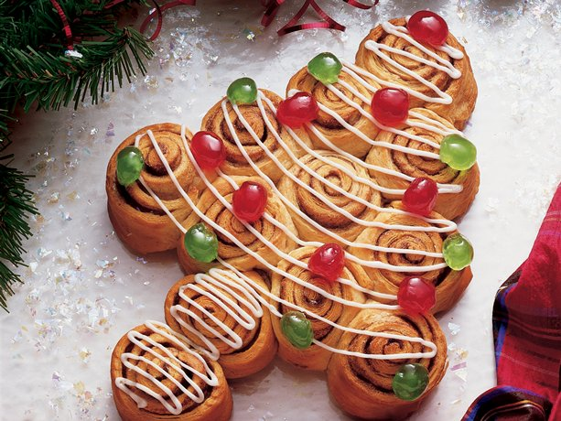

**Bread**

**2 (8-oz.) cans Pillsbury® Refrigerated Crescent Dinner Rolls**

**2 tablespoons margarine or butter, softened**

**2 tablespoons sugar**

**1 teaspoon cinnamon**

**Glaze**

**½ cup powdered sugar**

**¼ teaspoon vanilla**

**2 teaspoons milk**

**Garnish**

**Red and green candied cherries, halved or colored sugars**

1. Heat oven to 375°F. Lightly grease cookie sheet. Separate dough into 4 rectangles. Firmly press perforations to seal. Spread rectangles with margarine. In small bowl, combine sugar and cinnamon; sprinkle evenly over rectangles.
2. Starting at shorter side, roll up each rectangle; seal edge. Cut each roll crosswise into 3 equal slices. Place slices, cut side down, on greased cookie sheet to form tree shape. Begin with 1 slice for top; arrange 2 slices just below, with sides touching. Continue arranging a row of 3 slices, then a row of 4 slices. Use remaining 2 slices for trunk.
3. Bake at 375°F. for 15 to 20 minutes or until deep golden brown. Cool 3 minutes; carefully remove from cookie sheet. Cool slightly on wire rack.
4. In small bowl, blend all glaze ingredients until smooth, adding enough milk for desired drizzling consistency. Drizzle glaze over warm tree. Garnish with candied cherry halves. Serve warm.

Makes 12 rolls